CMSC 204

Huffman Lab

1. Create a Huffman Tree and generate the codes for each character of the following input:

create a huffman tree

For consistency:

1. If same frequency – put in priority queue alphabetically; put space before other characters of the same frequency
2. Add subtrees to end of group with same priority
3. Lower number has higher priority (goes to front)

|  |  |  |  |  |  |  |  |  |  |  |  |  |  |  |  |  |  |  |  |  |
| --- | --- | --- | --- | --- | --- | --- | --- | --- | --- | --- | --- | --- | --- | --- | --- | --- | --- | --- | --- | --- |
| c 1 | h 1 | m 1 | n 1 | u 1 | f 2 | r 2 | t 2 | 2- | 2- | spce 3 | a 3 | 3 | e 4 | 4 | 4 | - 6 | - 7 | 8 | - 13 | 21 |

21

8

13

6

4

a

spa

e

3

4

f

u

t

r

2

2

n

m

c

h

7

Now encode “create a huffman tree”

0000010100111011100110111110000110101011101100101110011110011010100100

1. Based on the following Huffman tree and binary sequence, what is the text

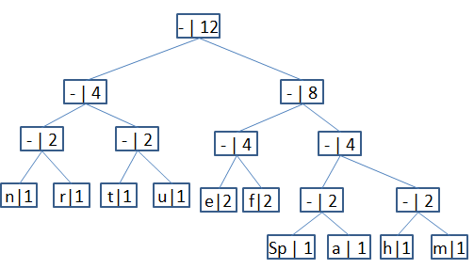

1110011101101111111010001100010001100100

huffman tree